**CS691 - Computer Science Fall 2020**

**Project Initiation Document**

**Stream Feeder**

Project: Stream Feeder

Project Manager: Manisha Dagduji Shinde

Table of Contents

Document Purpose 4

Background to the Proposed Work 4

Vision 4

Project Objectives 5

Project Scope 5

Business Case 5

Assumptions 7

Risk Management Strategy 7

Deliverables 9

Stakeholders 10

Internal Stakeholders 10

External Stakeholders 10

Project Team 11

RACI Table 12

Project Plan 13

Project Controls 13

Communication Plan 14

Document Details

|  |  |  |  |
| --- | --- | --- | --- |
| **Version** | **Modifications** | **Author** | **Date** |
| **2.0** | Initial PID Document | Manisha Dagduji Shinde | 09/20/2020 |
|  |  |  |  |
|  |  |  |  |
|  |  |  |  |

Approvals

This document requires the following approvals:

|  |  |  |  |  |
| --- | --- | --- | --- | --- |
| **Name** | **Role** | **Signature** | **Date** | **Version** |
| **Prof. Yuri** | Approver |  | 09/08/2020 | 2.0 |

Distribution

This document has been distributed to:

|  |  |  |  |
| --- | --- | --- | --- |
| **Name** | **Role** | **Date of Issue** | **Version** |
| Manisha Dagduji Shinde | Project Manager |  |  |
| Stephen Cahill | Lead Developer |  |  |
| Prajakta Chandrakant Jathar | Product Owner |  |  |
| Daniel Terach | Lead Business Analyst |  |  |
| Dachao Zhong | DBA |  |  |
| Sumant Mahendra Watekar | Lead QA Analyst |  |  |
| Sumant Mahendra Watekar | Tester |  |  |

# Document Purpose

This document has been created to record the basic information needed to manage the project. The document will describe the scope, objectives, tasks, roles and responsibilities, costs and deliverables related to “Stream Feeder” website.

The PID dictates the following critical aspects:

* Details of the approach to be adopted for the implementation of the “Stream Feeder” Project.
* Details of the roles and responsibilities.
* Description of functions and activities.
* Explanation of the processes.
* Details of the communication plan between team members and with the stakeholders.
* Quality records, risks, project controls and exceptions.

The sections of this document are dynamic and could potentially change over the lifetime of the project. The changes will be recorded in the PID document. The PID will be referred each time when a major decision is taken about the project. Also, the PID document will be used at the end of the project to measure whether the project was managed successfully or not and weather all deliverables were produced in timely manner or not.

# Background to the Proposed Work

According to pewresearch.org, Reddit, Twitter, Facebook, and Instagram are among the 9 most popular social media sites. In 2005, approximately 5% of surveyed adults in the US used some form of social media. By 2019, that figure reached over 70%. A multitude of people use different social media outlets, visiting each more daily. A 2018 survey found that among US adults who use Facebook, 51% of them use it more than once a day. Similarly, of US adults who use Instagram, 42% visit it more than once a day and for Twitter, 25% visit it more than once a day. There is a large percentage of the population who utilize these applications multiple times per day. Wouldn’t it be convenient if you could open a single app and see the most relevant posts from each of these social media giants?

Stream Feeder aims to be a social media conglomeration, where the user can seamlessly view multiple social media outlets all at once. Users will maintain the ability to favorite/like posts, providing for a familiar experience. Stream Feeder plans to combine the best features of social media, and put it into a single, easy-to-use application.

# Vision

The goal of this project is to provide a unique solution for social media browsing, simplifying the process for the user. This application will provide a sleek user interface by which the consumer can peruse a plethora of different social media sources, including popular outlets such as Reddit, Twitter, Facebook, and Instagram.

# 

# Project Objectives

* Modern web application to manage and streamline multiple social media platforms
* Single login to multiple social networking sites
* All content in one beautiful modern user-friendly UI
* User information will be stored in relational database
* Will be integrating with one social media platform (i.e. Reddit).

# Project Scope

Technical:

* We will be implementing our application using a UI framework called Ionic which
* Utilizes the Angular framework under the hood
* Responsive design integration

Functional:

* The application will be able to handle notifications from the multiple social medias
* Ads implementation for revenue generation
* Goals to achieve MYP (Minimum Viable Product)
* MVP has a functioning user login portal.

# Business Case

|  |  |
| --- | --- |
| **Type of business model** | Ad-based, freemium |
| **Target audience of users** | Social media users (everyone) |
| **Value proposition** | Stream-feeder will utilize API’s of popular social media applications to aggregate them in one application with a super-sleek UI.. |
| **How the system is used** | Users will be able to log in and access multiple social media outlets in one convenient location. As it currently stands you have your reddit, your Instagram, your Tiktok, your Twitter, your Facebook all in disparate places with separate sign-on.  “But I want my content all in one easy to use application that’s fun and easy to use and has a beautiful modern UI.”  Yes, dear user, we at Stream-feeder know you do. And we’re here to help. |
| **Partners/Suppliers**  **(Stakeholders)** | * Selling Ads * Option to upgrade to freemium subscription with additional features/functionality |
| **Expected Benefits** | * Non-stop content for voracious consumers * No switching between apps just to access all of the user generated streams you know and love * Single sign on (SSO) makes getting straight to content fast and easy |
| **Known Prototypes** | * <https://baconreader.com/> * <https://apps.apple.com/us/app/tweetbot-3-for-twitter/id1384080005?mt=12> * <https://play.google.com/store/apps/details?id=com.rubenmayayo.reddit&hl=en_US> |

**Constraints**

1).According to the guideline of course, the deadline will be Nov 10, our team will have 8 weeks to finish basic functions of the application and implement an available demo.

2).Developing the application for mobile(IOs and android) or Web users, different IUs to optimize each system experience will be taken in further consideration.

3).Available of APIs of multiple third parties.

4).Available of funding and advertising management.

# Assumptions

Team Assumptions

* All team members will complete assignments and tasks by deadlines as discussed in team meetings
* Team members will communicate any concerns or conflicts regarding the project in a professional and respectful manner
* As this is a learning experience for all of us, team members will not be afraid to ask questions as they arise.

Product Assumptions

* There is an unmet need in current application offerings for a web application that can integrate different social media feeds into one interface. Our product differentiates itself from others in the market through superior design and functionality.
* The web is the best default platform for the development and accessibility of our application. While native applications are still integral to the current application ecosystem, the web offers greater flexibility and tools. HTML, Typescript and CSS are more widely known than Swift or other mobile platform specific programming languages; a web-first approach will allow our project team to work more efficiently and effectively.

# Risk Management Strategy

Risk management is one of the most important jobs for a project manager. Risk management planning is the process of developing options and actions to enhance opportunities and reduce threats to project objectives. Risk management implementation is the process of executing risk mitigation actions. Risk mitigation progress monitoring includes tracking identified risks, identifying new risks, and evaluating risk process effectiveness throughout the project.

Commonly, risks are classified by what they can affect:

* Project risks
* Product risks
* Business risks

Risk management includes four stages as the RMS diagram shown below.

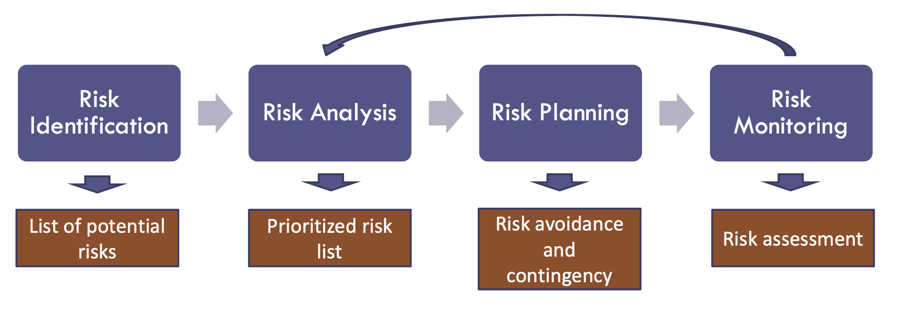

**Risk events assessed as Medium or High Criticality**

**Might go into risk mitigation planning and implementation**

**Low Critical risks might be tracked/monitored on a watch list.**

|  |  |  |  |
| --- | --- | --- | --- |
| **Risk** | **Probability** | **Impact** | **Mitigation Method** |
| Losing efficacy of multiple third party API | Low | high | Due to highly dependency on third party APIs, it is important to keep these APIs available for normal operation. Once it loses efficacy, a secondary work plan or replacement method might be needed to keep the application work. |
| The project is behind schedule | High | High | When the project schedule doesn’t reach the expectation, abandon unnecessary functions or features and focus on main functions to ensure the application is deliverable. |
| Technical hurdles that can't be bypassed | Medium | High | Choosing an appropriate system and framework for developing the application can avoid most technical difficulties by the support of Official technical documentation.  Also, a standard project flow is important to find out potential technical problems earlier and lower the time cost of rework. |
| Compatibility problem of application | Medium | Medium | Increasing test times and more application scenarios can help finding out the problems. Developing based on an appropriate framework can also avoid most predictable compatibility problems. |

# Deliverables

|  |  |  |
| --- | --- | --- |
| **Project Phase** | **NO** | **Deliverables** |
| Project Planning | 1 | Project Plan |
|  | 2 | PID document |
| Requirements Analysis | 3 | BRM Diagram; User Roles |
|  | 4 | Context Diagram; System Interface Table |
|  | 5 | Architecture Diagrams (Logical, Process views) |
|  | 6 | Business Requirements |
|  | 7 | RCT (includes func. decomp., suppl. reqs) |
|  | 8 | Use-Case Diagrams (UML) |
|  | 9 | Activity Diagram (UML) |
|  | 10 | Data-flow Diagrams (logical, physical) |
|  | 11 | Functional Requirements (user stories) |
| High-level Design | 12 | Class Diagrams |
|  | 13 | Sequence Diagrams |
|  | 14 | ER Diagrams (conceptual, logical) |
|  | 15 | Table Specifications (Data Dictionary) |
| Implementation | 16 | Source Code sample (part of Demo) + GitHub repository slides (images) |
| Testing | 17 | Test Plan document |
| Project Presentation | 18 | Presentation, Application Demo |

# Stakeholders

“A system stakeholder is anyone who should have some direct or indirect influence on the system requirements. Stakeholders include end-users who will interact with the system and anyone else in an organization who will be affected by it. Other system stakeholders might be engineers who are developing or maintaining other related systems, business managers, domain experts, and trade union representatives.” -Somerville pg. 103

“A formal definition of a stakeholder is: ‘individuals and organizations who are actively involved in the project, or whose interests may be positively or negatively affected as a result of project execution or successful project completion’ (Project Management Institute (PMI®), 1996). Project stakeholders usually include the project manager, the customer, team members within the performing organization, and the project sponsor.” -Larry W. Smith, PMP, Project Manager, Software Technology Support Center (<https://www.pmi.org/learning/library/stakeholder-analysis-pivotal-practice-projects-8905>)

# Internal Stakeholders

|  |  |
| --- | --- |
| **Stakeholder** | **Interest** |
| Project team | All members of the project team have a stake in the efficient and successful execution of the project. |
| Project sponsor | The project sponsor will be providing the funding for the project and, as the provider of our most important resource, is the most important internal stakeholder. |

# External Stakeholders

|  |  |
| --- | --- |
| **Stakeholder** | **Interest** |
| End users - (individual social media users, bands, businesses, marketers) | Most important external stakeholder and primary source of revenue generation. Our application must be developed with the end users at the forefront of our development efforts |
| Third-party applications | Considering we will be using APIs of third parties to implement our app, these third parties are stakeholders in that we will be utilizing their data, technologies and platform. The project must adhere to the user protocols as described in the API documentation. The success of our app also depends on the reliability and speed of data delivered through these APIs. |
| Advertising partners | These partners will be a source of our revenue generation. They have a stake in the click-through-rate and revenue generated through the users on our platform. |

# Project Team

The project team includes the following roles:

* Project Manager – Manisha Dagduji Shinde
* Product Owner – Prajakta Jathar
* Lead Developer – Stephen Cahill
* Business Analyst – Daniel Terach
* QA Lead/ Tester – Sumant Mahendra Watekar
* DBA – Dachao Zhong

# RACI Table

Roles and Responsibilities of the team roles are defined in the RACI Table below:

|  |  |  |  |  |  |  |  |
| --- | --- | --- | --- | --- | --- | --- | --- |
|  |  | **Project Roles** | | | | | |
| **Process Area** | **Project Tasks** | Project Manager | Product Owner | Dev Lead | Business Analyst | QA/Tester | DBA |
| Project Management | Develop a project plan | A,R | C | C | C | C | I |
| Provide cost estimate | A,R | C | C | C | C | C |
| Establish a project portal on SharePoint | A,R | R | I | I | I | C |
| Maintain a project risk and issue log | A,R | R | C | C | C | C |
| Provide project status reports | A,R | I | I | I | I | I |
| Requirements | Perform requirements analysts | A | R | R | R | C | C |
| Gather business requirements | A | C | I | R | I | I |
| Produce functional requirements | A | I | C | R | C | I |
| Design | Produce high-level design specs | A | I | R | C | C | R |
| Produce data model | A | I | C | I | I | R |
| Produce detailed design specs | A | I | R | I | I | R |
| Coding | Establish a code repository | A | I | R | I | C | C |
| Develop component code | A | I | R | I | C | C |
| Testing | Develop a test plan | A | C | C | I | R | I |
| Establish a test repository | A | C | C | I | R | I |
| Develop test specifications | A | C | C | I | R | I |
| Execute testing, report defects | A | I | I | I | R | I |
| Conduct defect review calls | A | I | C | R | R | C |
| Produce, deliver defect metrics | A | I | C | R | R | I |
| Support test environments | A | I | R | C | C | R |
| Deployment | Produce a deployment plan | A | I | R | C | I | I |
| Produce deployment procedures | A | I | R | I | I | I |
| Deploy software into production | A | C | R | C | C | I |

# 

# Project Plan

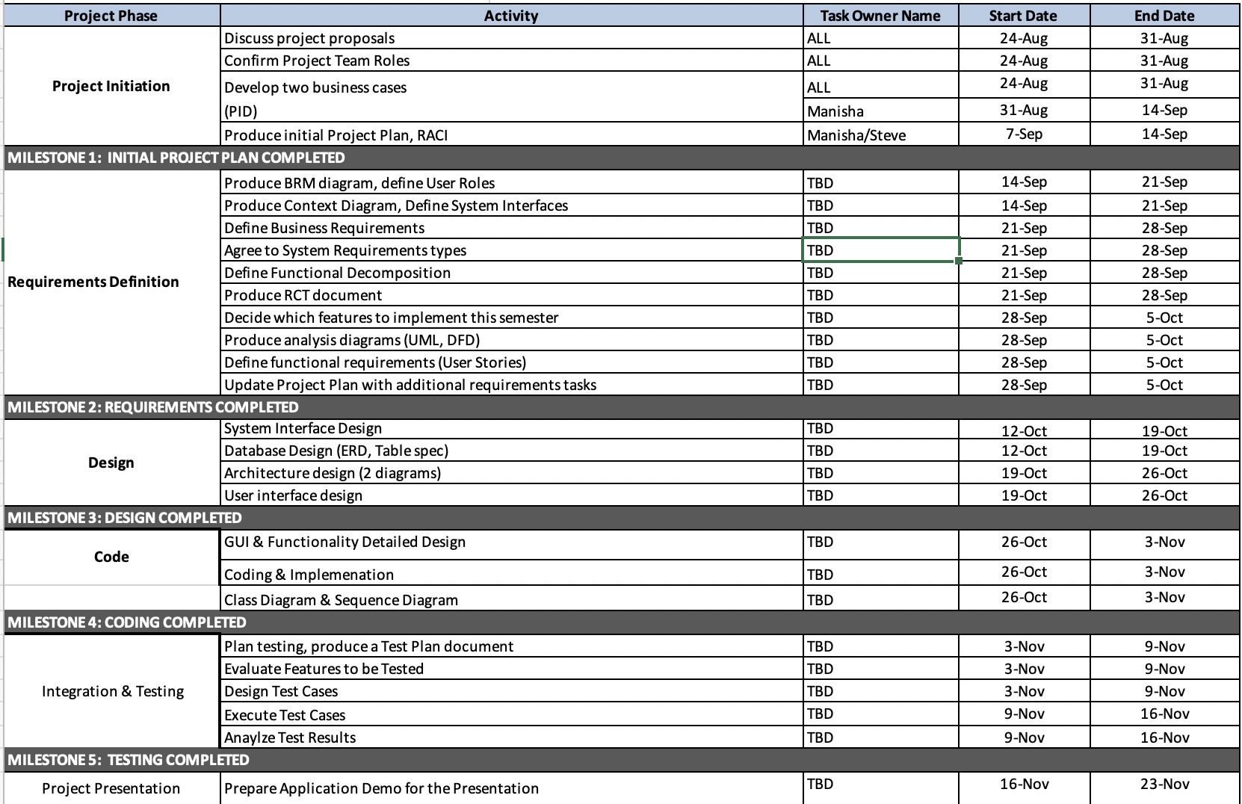

# Project Controls

Official language of the project will be English. Official meetings will be held in English. All project documentation and presentations will also be written in English.

Project manager will be organizing two weekly meetings. All the team members are allotted their work that has to be completed before each week

In case any member cannot make for the meeting, manager should reschedule a meeting or held it online through Skype or Google Hangouts. The most of the asynchronous communication will be done on Skype for Business.

Important points and topics will be discussed in the meetings. Final decisions will be made by the end of the meetings taking everyone’s opinion in the consideration.

Weekly meeting minutes will be maintained by the project manager which will also include the progress of the project phases. Manager will also keep a track of the deadlines and ensure that everyone plays their role accurately.

WhatsApp and Google drive will be used to update all the team members with the important information by the manager and for sharing all the files.

# 

# Communication Plan

|  |  |  |  |
| --- | --- | --- | --- |
| **Stakeholder** | **Frequency** | **Type** | **Purpose** |
| **Project Manager** | Daily | Slacks, Emails, Skype for Business/ Zoom Meeting, Phone call | Discuss all project points in meetings & note down meeting minutes, assign roles & responsibilities within the team. Review all assign work. Discuss any new technical features required in project. |
| **Project team** | Daily | Slacks, Emails, Skype for Business/ Zoom Meeting | Discuss all project points in meetings, discuss work in progress. New requirements. Their defects, their solutions & potential issues. |
| **End users** | Potentially during the testing phase and after release. | Email, Online Testing sessions. | To obtain feedback!! |
| **Quality Management Team** | Daily | Emails, Skype for business / Zoom Meetings | To ensure that all key processes are implemented correctly. |